Session-4

New ABAP syntax:

This is not mandatory use this syntax.

New Changes on SQL:

* Pass literals in SQL language.
* Escaping of host variable
* We can specify the column separated by comma(,)
* Use the new SQL functions Ex: CEIL, COEALESE…
* Able to use the CASE expressions
* Join you can use it more than 20 joins in single query.
* Use aggregate functions inside CASE and HAVING clause also.

ABAP Language Enhancements:

* Inline data declarations
* String Operator for concatenate(|)
* Value expressions
* Table Expressions
* Corresponding #: used to transfer data from one table to another.
* New syntax to create the class and objects like C++

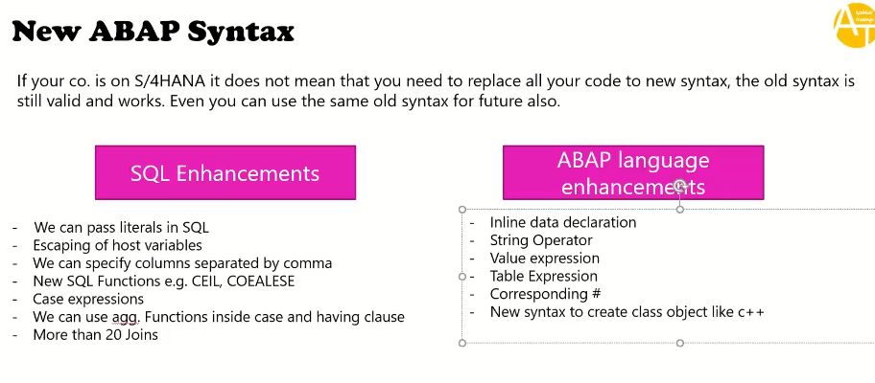

Creating new program in hana studio:

* Right click on PKGE.

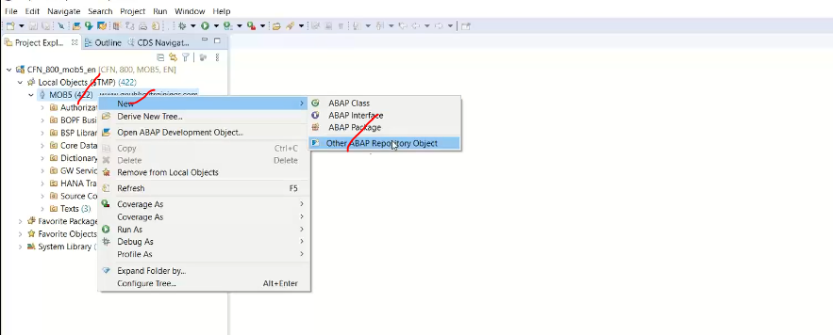

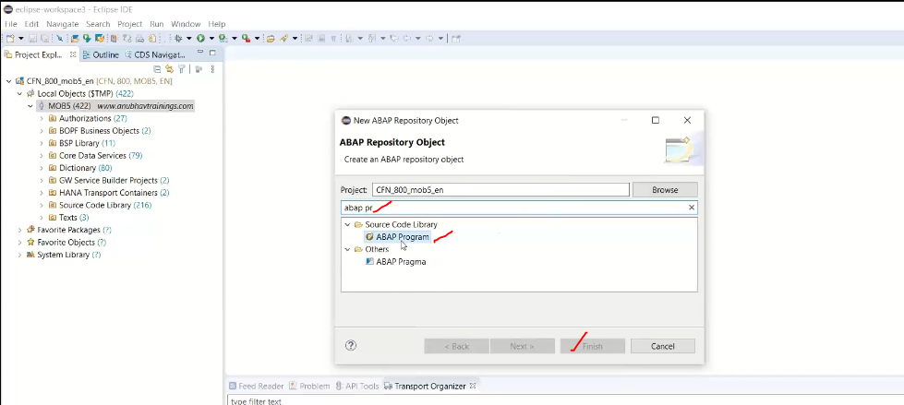

Provide abap program name and Description

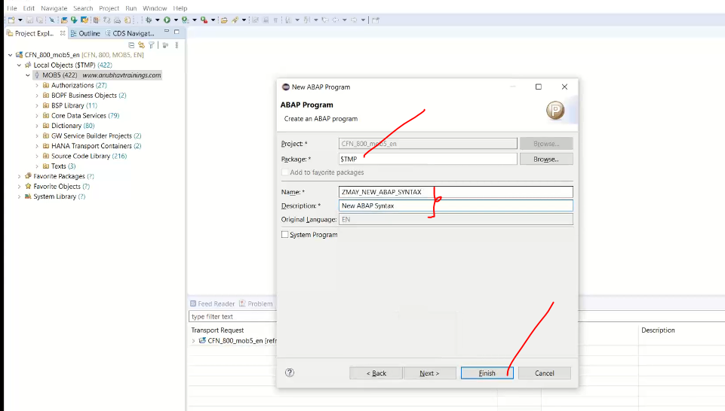

Click on finish in next screen.

* Don’t use * in columns place at select statement.

Program: it is giving error, while you will not taking the escpe(@) character in select statement.

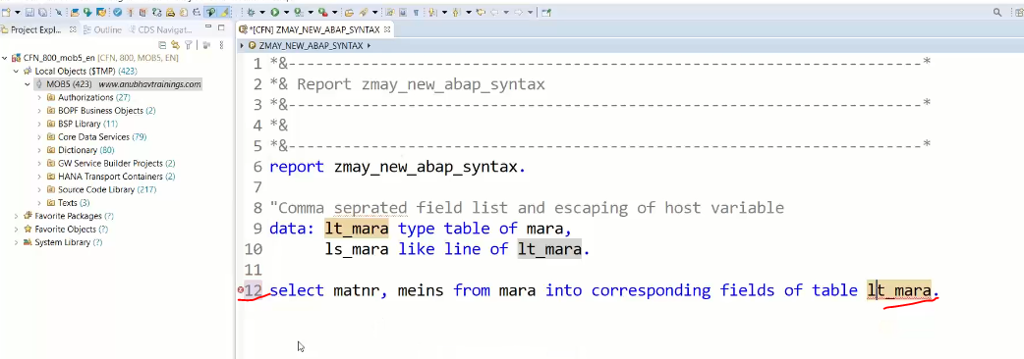

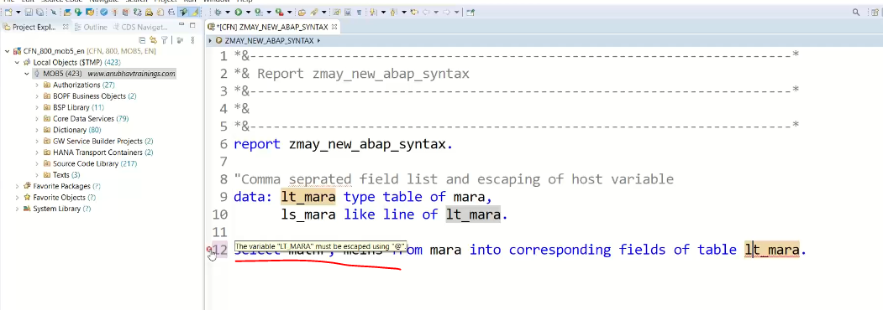

@lt_mara in select statement:

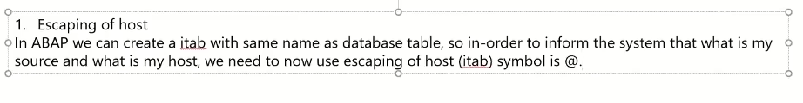

Ex:

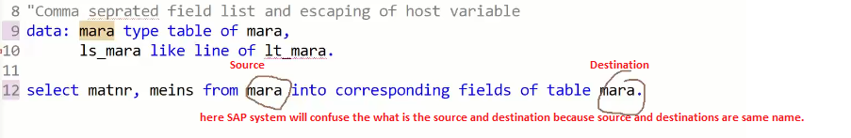

To avoid this confusion in select statement destination variable always begin with escape character.

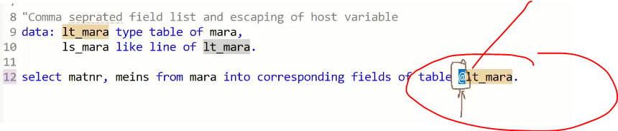

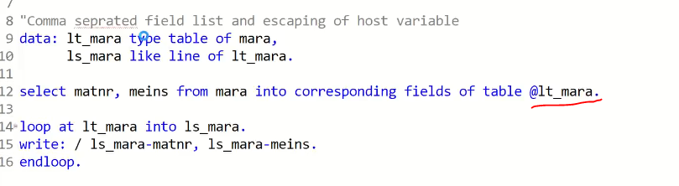

Output:

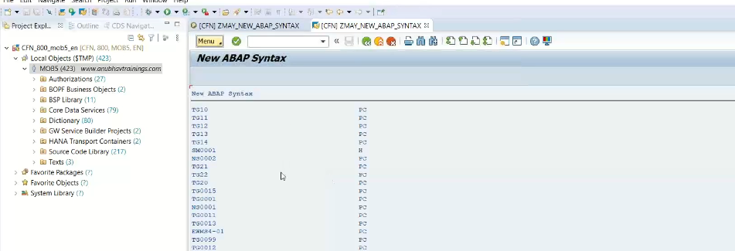

Ex-2 Inline Data Declarations

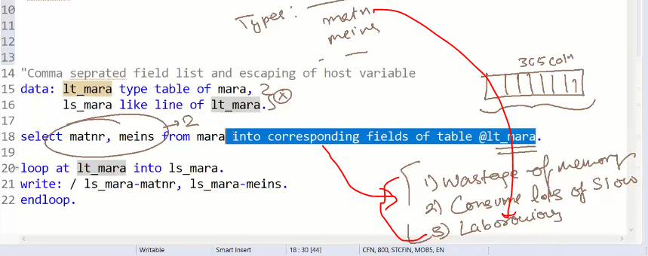

So avoid all these draw backs we can use it as inline declarations.

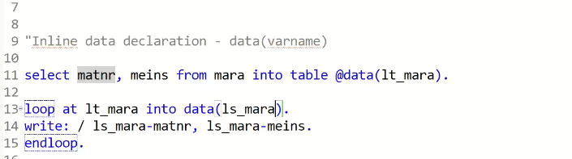

@ use it in select statement and data bse opertions mstsc

@ escaping of host variable.

@ comes in SQL only

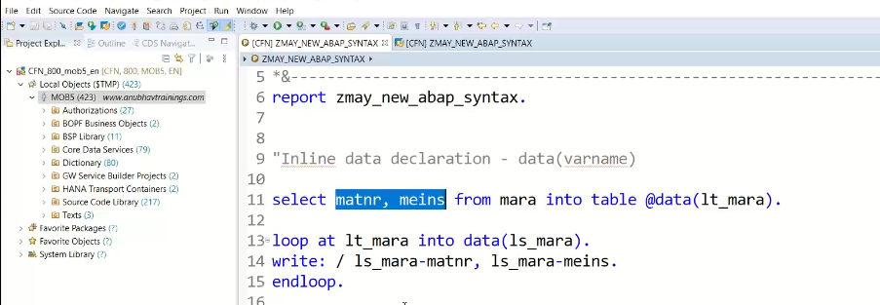

Use: never come incomparability dumps with inline declarations.

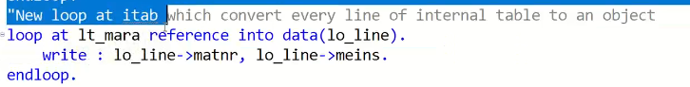

How to convert internal table line to an object.?

<<<<<<<<<<<<<<<<<<<<<<<<<<<<<<<<<<<<<>>>>>>>>>>>>>>>>>>>>>>>>>>>>>>>>>>

Inline Field Symbol declarations:

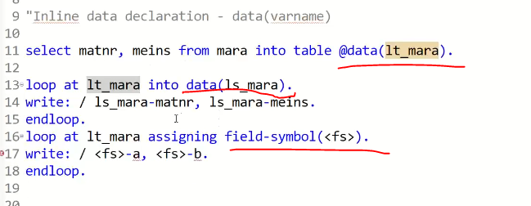

<<<<<<<<<<<<<<<<<<<<<<<<<<>>>>>>>>>>>>>>>>>>>>>>>>>>>>>>>>>>>>>>>>>>>>>>>>>

Literals in SQL statement:

* Concatenate literals in select statement.
* && used for concatenate.
* Or use the Concatenate function

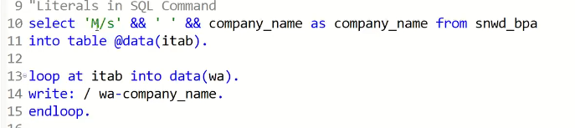

Output:

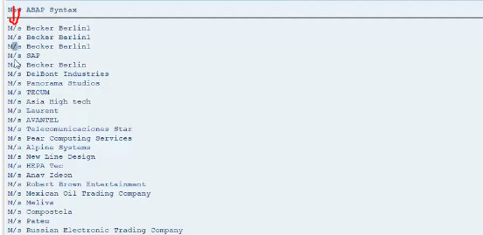

Where exactly this concatenate happening ? it is happening in hana layer.

<<<<<<<<<<<<<<<<<<<<<<<<<<<<<<<<<<<<<<<>>>>>>>>>>>>>>>>>>>>>>>>>>>>>>>>>>>>>>>

SQL Functions:

Used to pushing the logic to HANA.

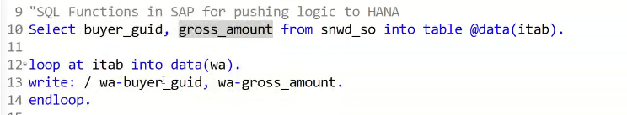

Output:

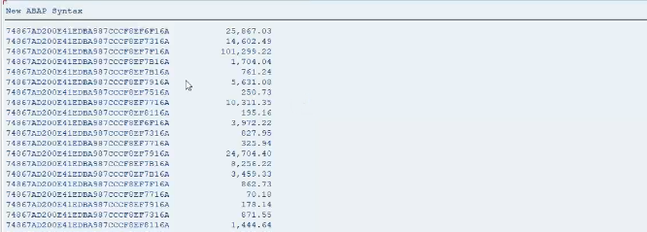

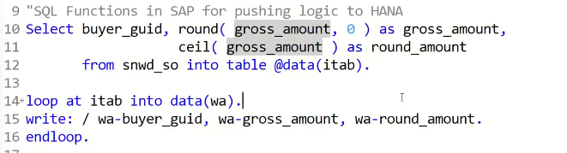

Output:

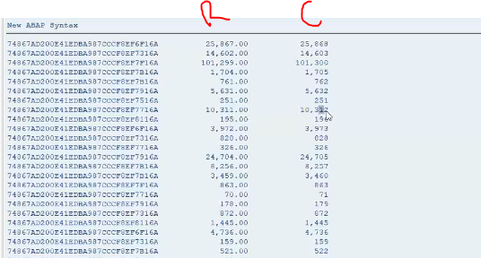

How to get the help from hana studio?

* Select the keyword and press F1

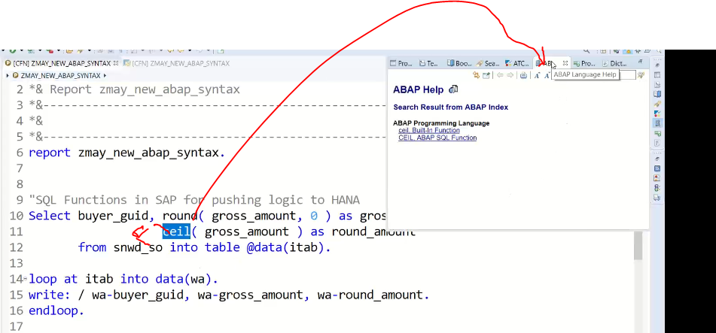

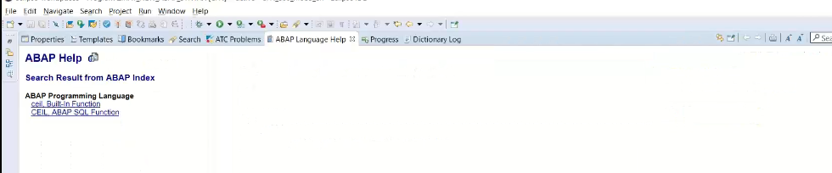

Click on CEIL ABAP functions

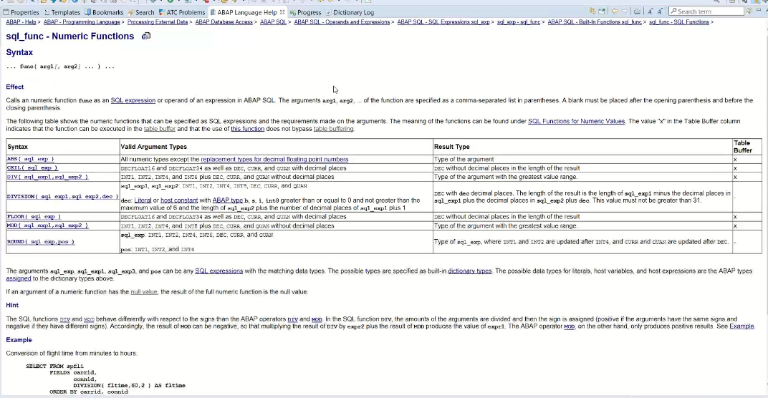

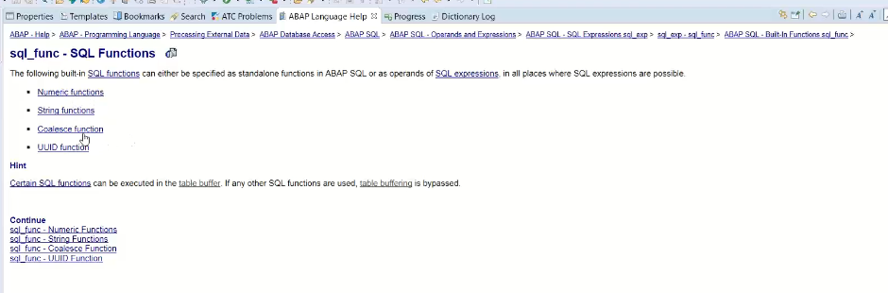

Round( amount, 0) 🡪 0- no decimal needed, rounding into zero decimals

Ceil( amount ) 🡪round of to the next biggest integer.

<<<<<<<<<<<<<<<<<<<<<<<<<<<<<<>>>>>>>>>>>>>>>>>>>>>>>>>>>>>>>>>>>>>>>>>>>>>>>>>>

CASE expression:

Some cases end user does not understand the 1, 2, 3 ,4 of bp_role, instead of 1, 2,3, 4 we need to give some meaningful information.

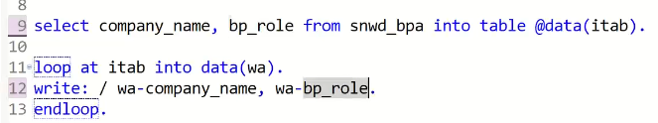

Output

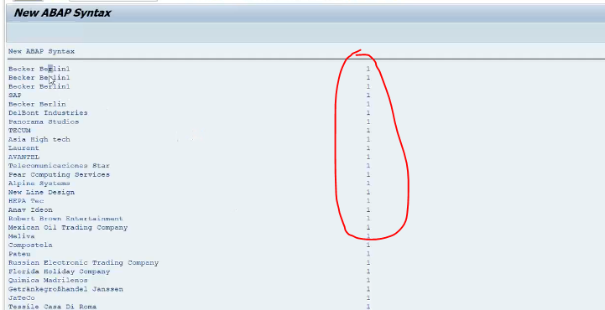

How to display data @1 –Customer, @2-Supplier, @4-Contractor

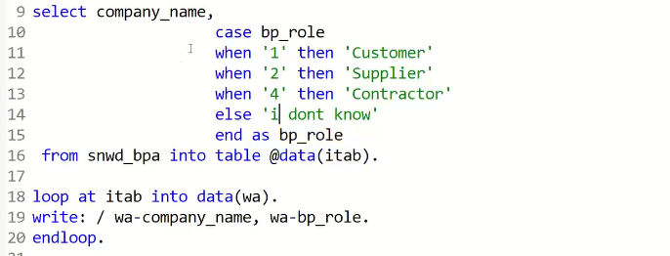

Output:

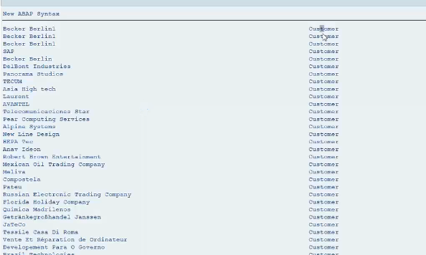

Complex case: to analyze customer sales order and categorized customer sales order amount has been exceeded , it say high value order else it medium value and else it is low value.

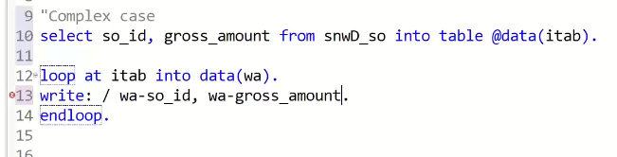

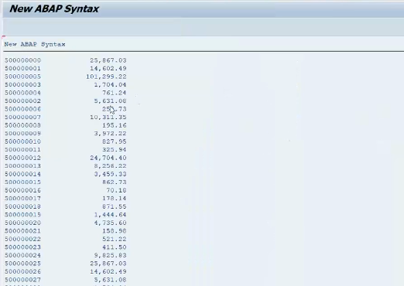

Exceeded 1,00,000 – highr order value high

25000-100000 – medium order(medium)

<25000 - low volume order.(low)

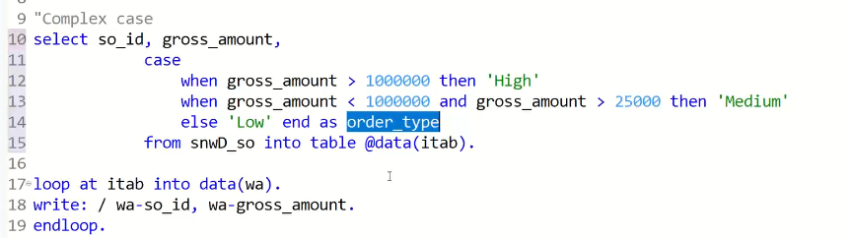

Output:

Q: if your company running on NW7.4 but DB is MAXDB/IBMDB/ORACLE will these code works in those data bases also.?

Ans: code will work(min NW version 7.4 ), but what will happen in these case may not get good performance because these expression computed by ABAP engine itself and they are not column store/multi core cpu,

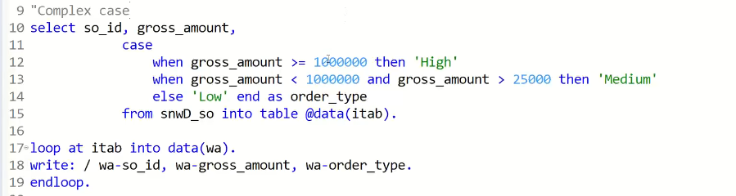

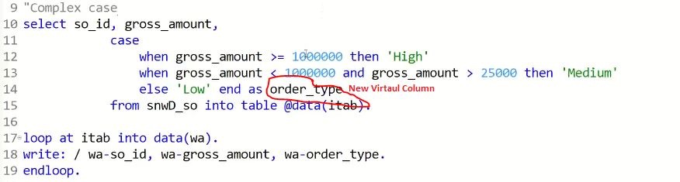

Virtual columns are dynamically created by system

If statement not work in SELECT statement.

Output:

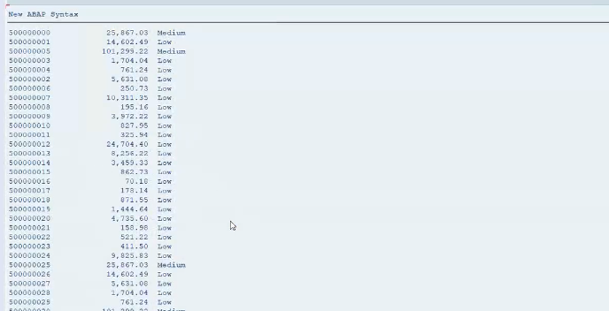

<<<<<<<<<<<<<<<<<<<<<<<<<<<<<<<<<<<>>>>>>>>>>>>>>>>>>>>>>>>>>>>>>>>>>>>>>>>>>>>>>>

Aggregate Functions inside the select:

For aggregate function, it is mandatory use the group by clause, it is mandatory to give the alias name for aggregate functions.

Req: Company look at total volume per customer.

Snwd_so-buyer_guid, 🡪 who bought the sales order.

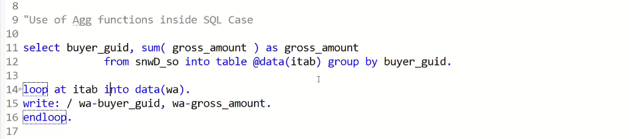

Output:

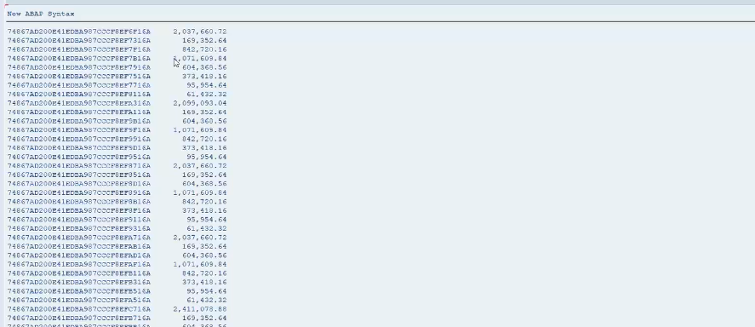

Show the orders only where gross amount greater than 200000 .

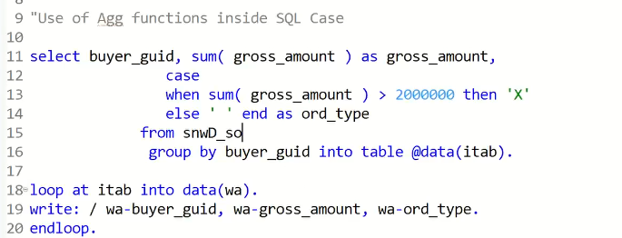

Sum(gross_amount) we can use it in case expression also.

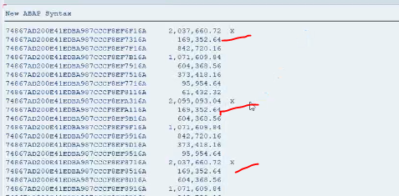

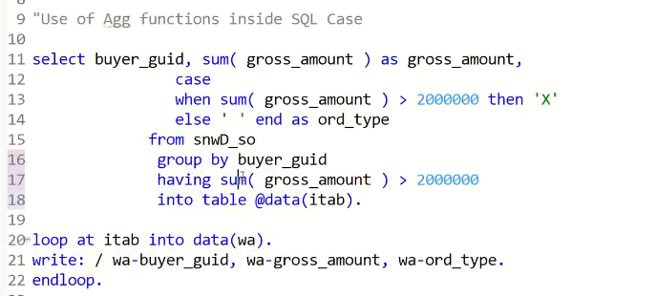

Output:

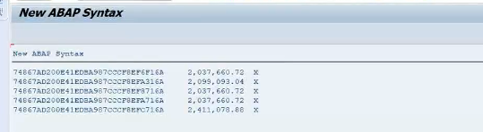

<<<<<<<<<<<<<<<<<<<<<<<<<<<<<<<<<<<<<<<<<<>>>>>>>>>>>>>>>>>>>>>>>>>>>>>>>>>>>>>

ABAP Enhancements:

Inline declaration 🡪 already seen

String Operator:

Concatenate: “|”

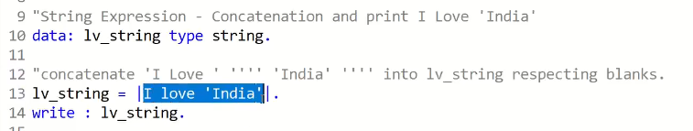

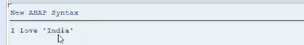

Change the country as a variable

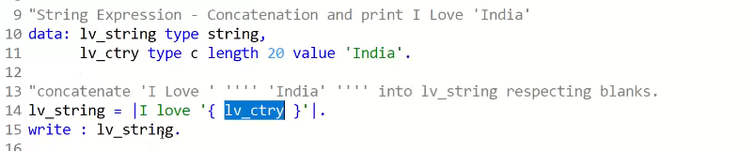

Output:

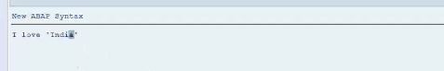

Date /integer/decimals/ -- everything work.

<<<<<<<<<<<<<<<<<<<<<<<<<<<<<<<<<<<<<<<<<<<<>>>>>>>>>>>>>>>>>>>>>>>>>>>>>>>>>>>>

VALUE expressions:

Use: add records to the internal table.(Column names are same )

Old code:

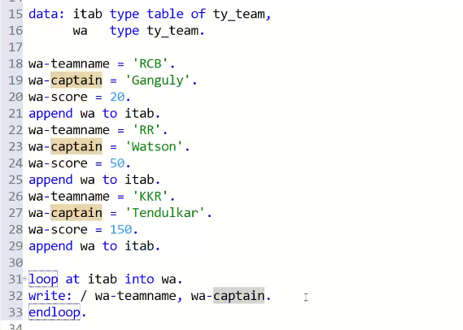

New code:

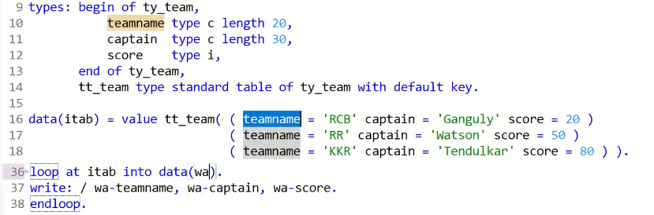

Output:

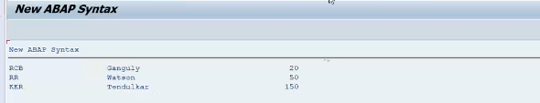

Corresponding:

Used to send data to the one internal table to other.

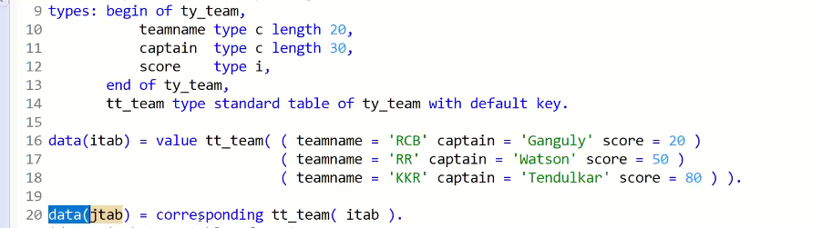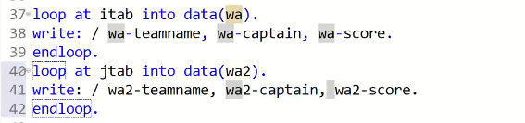

Output:

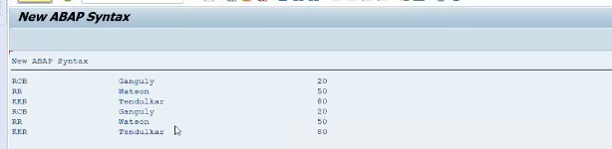

1:07:10

Column names are different.

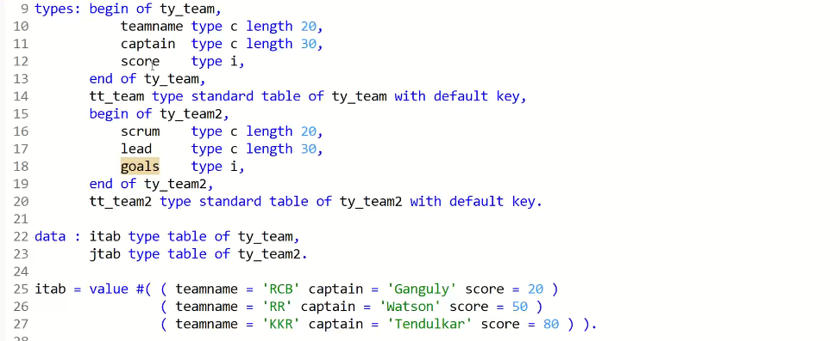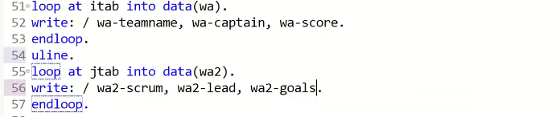

Here you will not able to get data from jtab, because data not transferred from itab since field names are different.

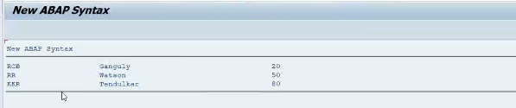

So this case we are using corresponding with mapping.



Note: field types are comparable. Else give the dump

Output:

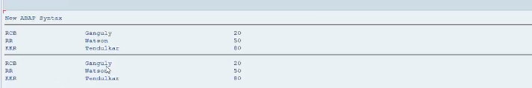

Adding 10% to the score filed using for loop.

In for loop wa is created automatically, no need to declare it.

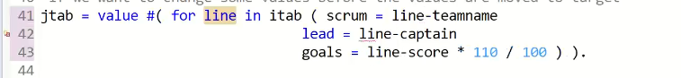



output

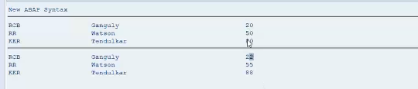

<<<<<<<<<<<<<<<<<<<<<<<<<<<<<<<<<<<<<<<<<<<<>>>>>>>>>>>>>>>>>>>>>>>>>>>>>>>>>>>>

Class Object:

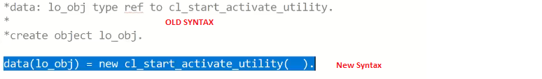

Read table:

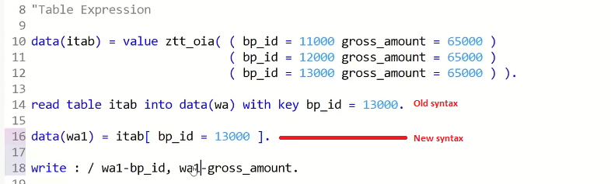

Output:

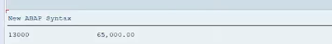

Note : new syntax very dangerous, if you put a value that is not avialble in internal table it will give the dump.

To avoid this we need to check the line_exists, after use the new read statement.

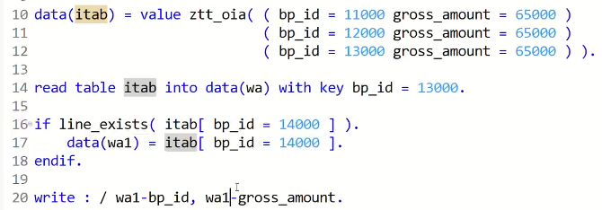

Note: Read or New Read statement, use always equal operator.

Output:

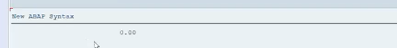

<<<<<<<<<<<<<<<<<<<<<<<<<<<<<<<<<<<<<<<<<<>>>>>>>>>>>>>>>>>>>>>>>>>>>>>>>>>>>>>>>>

Collect:

Old:

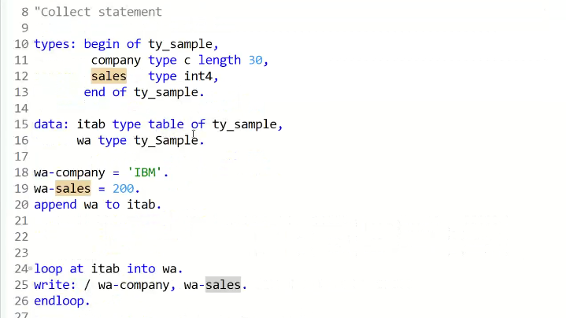

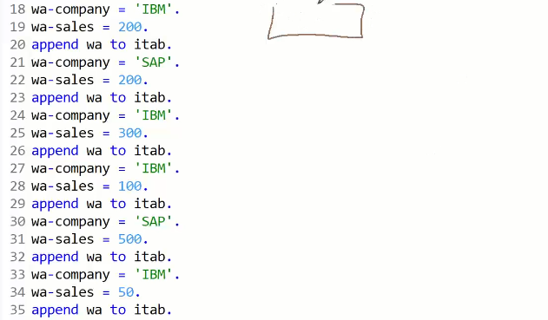

Use the collect instead of append, it is summing up to all numeric fields based non numeric key fields data

IBM 650

SAP 700

<<<<<<<<<<<<<<<<<<<<<<<<<<<<<<<<>>>>>>>>>>>>>>>>>>>>>>>>>>>>>>>>>>>>>>>>>>>>>

HANA

How ABAP needs HANA?

Connecting to HANA studio.

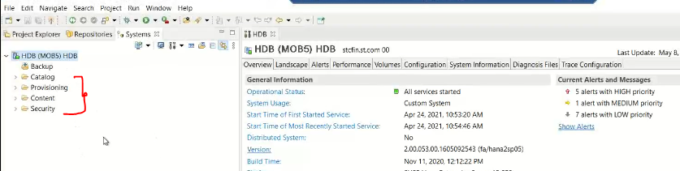

While login in HANA, you can see 4 folders.

1. Catalog
2. Provisioning
3. Content
4. Security

Security:

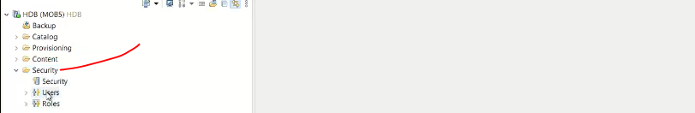

Here you can able to see all the users and roles.

Users: to see the all the users to login the system.

Roles: for security, these roles are granting to the users.

Security taken care by hana admin .

1:45:00

Provisioning:

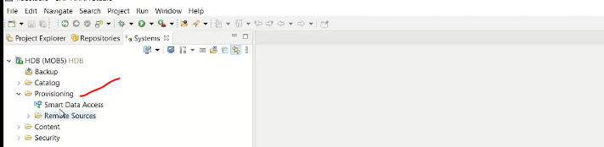

Taken care by HANA consultant

Here the provision to connect to the tools like BODS/SLT… transfer data from non sap to SAP viceversa.( to hana system, from hana system)

BACKUP:

Again used by HANA admin

* Take data to the backup.

<<<<<<<<<<<<<<<<<<<<<<<<<<<<<<<<<<<<<<>>>>>>>>>>>>>>>>>>>>>>>>>>>>>>>>>>>>>>>>

Most important part is content and catalog.

Content:

In Hana I have to the create the table

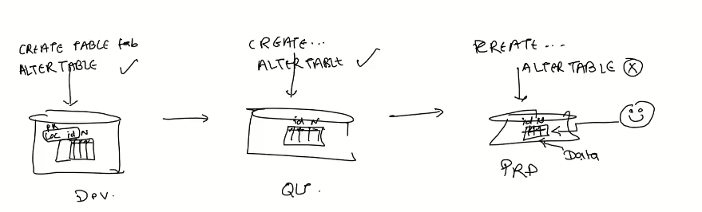

Table has data, if you try to change the primary key 🡪 in production may not work.

How to do it… copy data to temporary table and do the alter and then back data from temp to table.

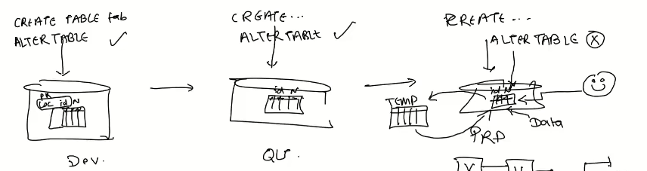

Never work runtime object directly ( which is physically stored in memory )

We are always work with design time object only

What is the design time object?

* Is the simple file, we have to write the commands to create the table.

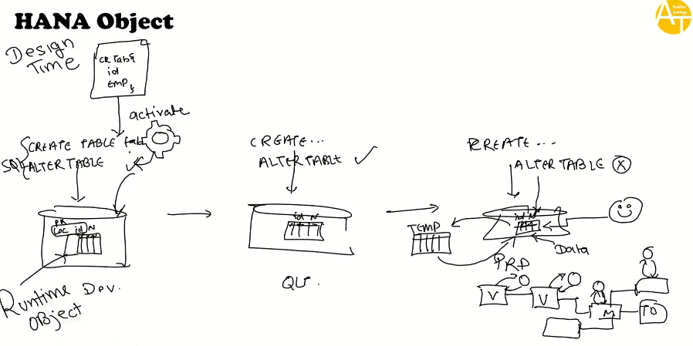

Once activate the file, hana engine create the sql and generate the runtime object called as table.

To create the table in quality and Production, we need to transport the design time object to higher environment, once receive the design time object in qty and production automatical happens the activate the design time object then runtime object generates.

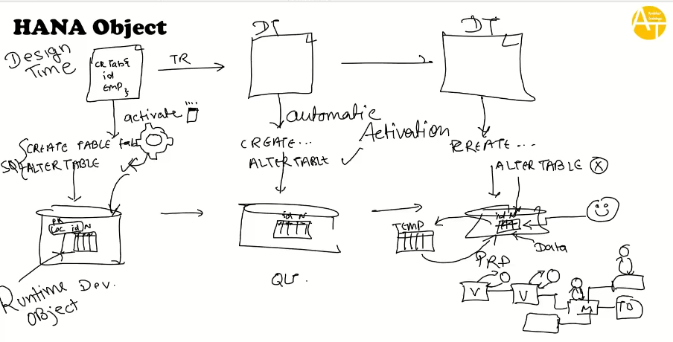

As adeveloper, we re working with design time objects only.

Runtime object is the physical DB.

Each design time object is different runtime object like table/views/procedures/triggers.

Where do you store design time objects? In hana we are storing packages.

Where runtime object stores? In HANA that is schema.

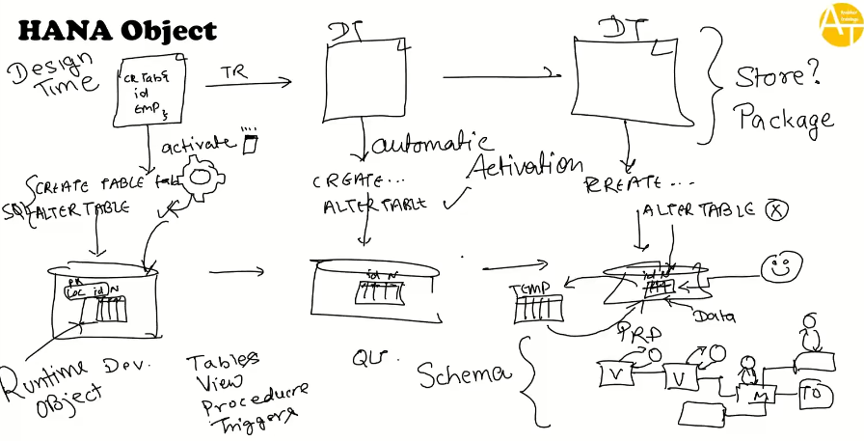

In HANA studio, if I go in content folder you can able to see all the packages.

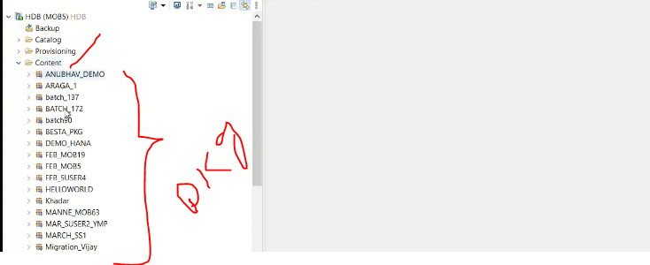

In side packages we have the design time objects.

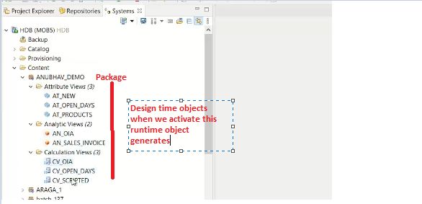

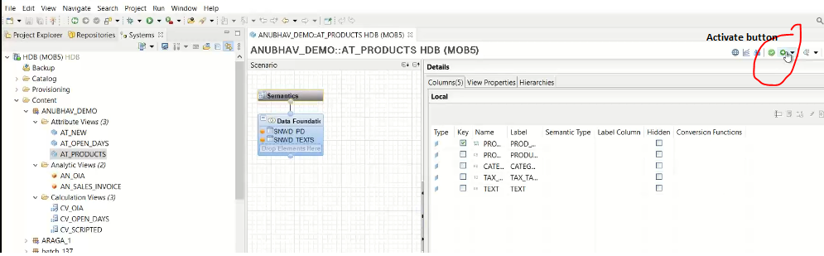

Note Runtime object generates inside schema.

Where schema is available in HANA studio.

Ans. Schema’s are stored in the CATALOG.

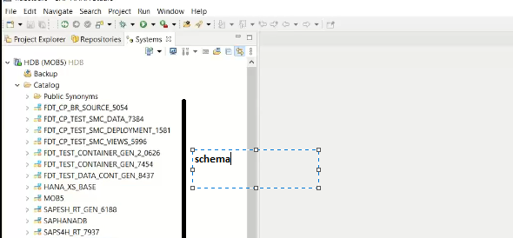

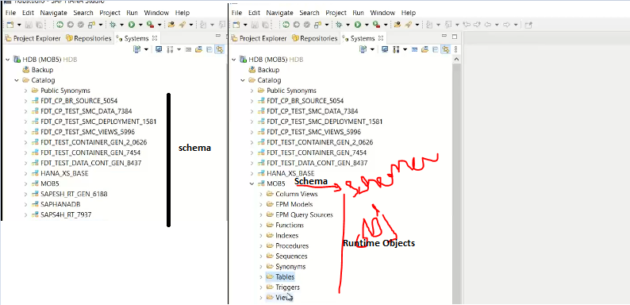

ABAP Packages and HANA Packages are different.

